**Registration on the Journal's website**

To register on the site, you need to follow the "Login / Registration" link in the upper right corner of the start page. Next, log in using your login and password, or click "Register" and enter your details in the registration form that appears. Required fields are indicated by a circle. After filling in all the fields, click the "Register" button. An email with a link to activate the account will be sent to the e-mail specified in the corresponding field of the registration form.

Then you can go to the "Submit article" section.

Uploading a new article to the Editorial System includes 5 steps:

* Step 1. Start.
* Step 2. Upload submission.
* Step 3. Enter metadata.
* Step 4. Upload supplementary files.
* Step 5. Confirmation.

**Step 1. Start**

Journal Section. Select the section of the journal to which the article will be submitted. To do this, open the list of sections. Select the section for the uploaded article from the drop-down menu.

Language of the article. If the journal accepts articles in several languages, select the language of the article from the drop-down menu. The main language of the journal is set by default.

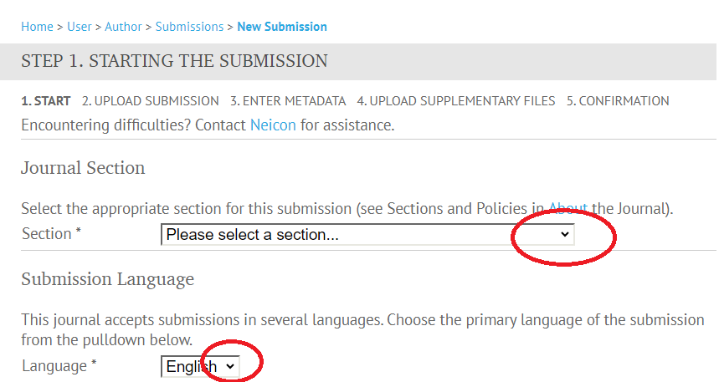

Requirements for the article. Confirm that the uploaded material complies with the norms and conditions accepted in the journal. To do this, click the checkpoints in all specified boxes. If this is not done, further uploading of the article will be impossible.

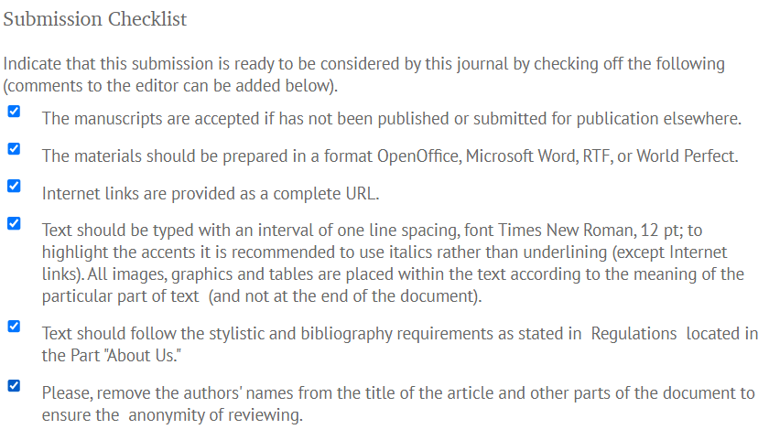

Comments for editors (optional). This is an opportunity to leave a comment for the editor in a free form. The comment will be visible to the editor(s) of the journal and the editor of the corresponding section.

Having filled in all the necessary fields in step 1, click "Save and continue" to continue (go to step 2).

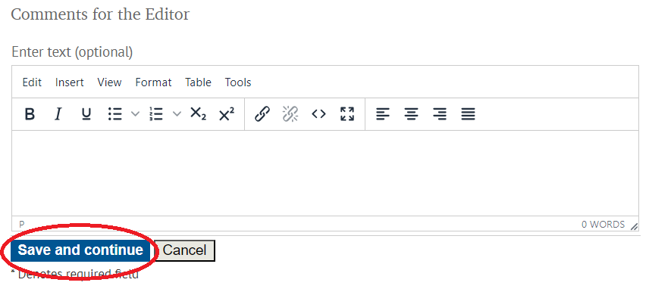

**Step 2. Upload submission**

Article file. Upload the file with the text of the manuscript designed according to **the template** to the Editorial System:

• Click "Select File" (Выберите файл)

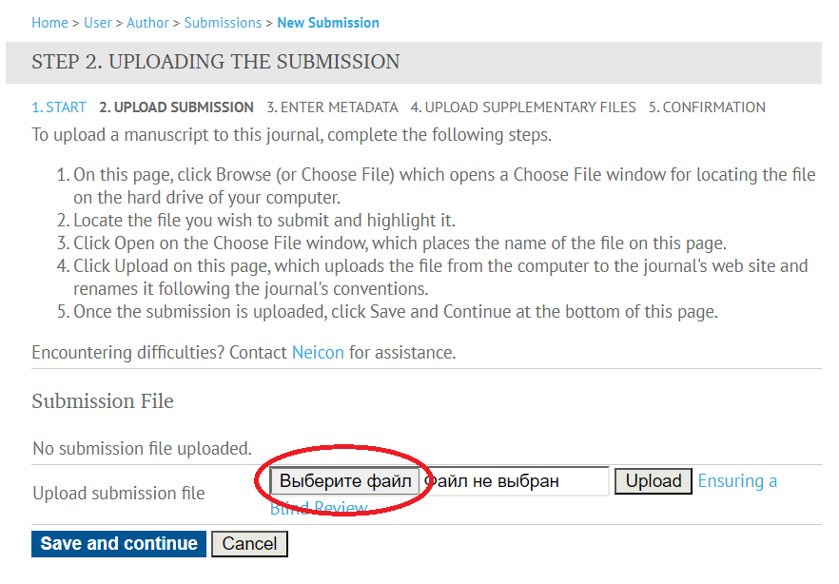

• Select the desired file on your computer.

• Click "Upload".

After uploading the material, the system will display the name assigned to the file, its original name, file size, date and time of upload.

Step 2 allows you to upload only one file to the system – a file with the text of the article.

* To continue (go to step 3), click "Save and continue".

**Step 3. Enter metadata.**

Enter the metadata of the article. Required fields are marked with *

(asterisk).

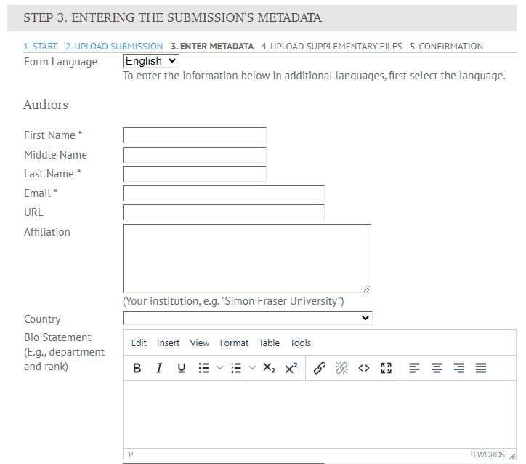

**Step 4. Upload supplementary files.**

In this section, you need to download the following MANDATORY documents:

1. **Author's consent** to the use of his or her personal data;
2. **Contract** for the right to use the article in open access must be concluded for each article. The contract must be signed by at least one author.
3. Act of identification examination (**expert opinion**) on the possibility of open publication is drawn up by the authors in the export control department of the university (DSTU employees draw up an expert opinion through their personal account in the system edu-donstu.ru).

Additional files include figures, tables, captions to figures and tables, if the editorial board requires them to be downloaded separately from the text.

After saving the first document, the "Step 4" page will open again, where the uploaded file will be displayed. The system will allow you to upload a second additional file (third, etc.).

If all the necessary additional files have been uploaded, click "Save and continue" to proceed to the next step.

**Step 5. Confirmation.**

After the main article file and all additional files are uploaded, click "Finish" to send the article to the Editorial Office of the journal.

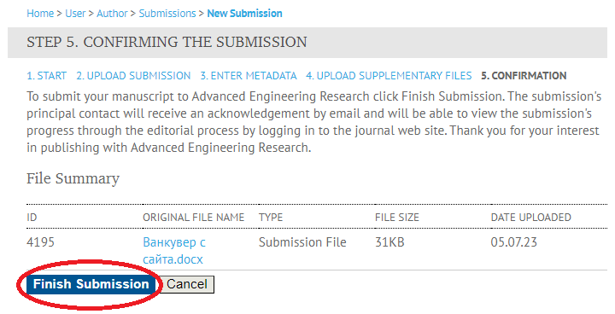

The author specified as a contact for communication with the Editorial Office will receive confirmation by e-mail and will be able to monitor the status of the article in his or her personal account on the Journal's website.